2023 Lancaster University

SCC 201 Lab Week 4

**Instructions:**

This week you will continue to work on the relational model.

**Task 1:**

(Windows)

Download sqlite3.exe Version 3.26.0 from Moodle page.

Go to the terminal and run sqlite3.exe

(Linux)

Goto the terminal and type sqlite3 and then press enter.

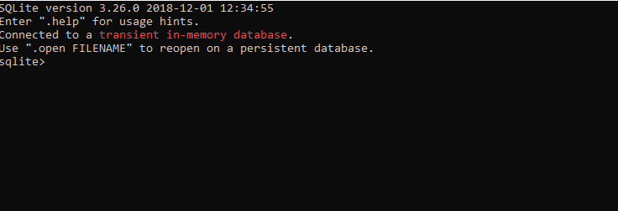

1. Execute the following DDL code.

CREATE TABLE Department(DName TEXT NOT NULL, HoD TEXT, NoOfEmp INTEGER, PRIMARY KEY(DName));

CREATE TABLE StudentsEnrol(firstName TEXT, lastName TEXT, RegNumber INTEGER NOT NULL, Address TEXT, BDate TEXT, Gender TEXT, DepName TEXT, PRIMARY KEY (RegNumber), FOREIGN KEY(DepName) REFERENCES Department(DName) ON DELETE SET NULL);

CREATE TABLE CourseRuns(CName TEXT NOT NULL, Desc TEXT, DepName TEXT, PRIMARY KEY (CName), FOREIGN KEY(DepName) REFERENCES Department(DName) ON DELETE SET NULL);

CREATE TABLE StTakesCourse(CName TEXT NOT NULL, RegNumber INTEGER NOT NULL, PRIMARY KEY(CNAME,RegNumber), FOREIGN KEY (CName) REFERENCES CourseRuns(CName), FOREIGN KEY (RegNumber) REFERENCES StudentsEnrol(RegNumber));

pragma table_info('StTakesCourse');

You should see a similar console as given:

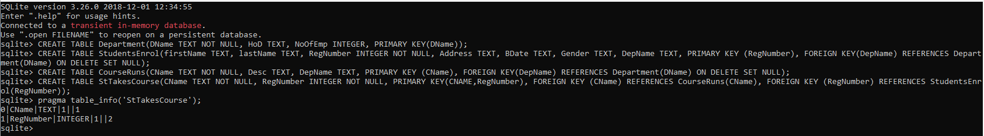

1. Insert some values of your choice to the tables using INSERT INTO <tableName> (AttributeName) VALUES (values); e.g.

INSERT INTO Department(DName,HoD,NoOfEmp) VALUES ("SCC","Nigel Davies",219);

1. Print the content of your tables using SELECT command; e.g.



1. Draw the ER diagram for the Database.
2. Execute the following code to remove tables

drop table StudentsEnrol;

drop table CourseRuns;

drop table Department;

drop table StTakesCourse;

Task 2: Create the ER Diagram, write the Relational Schema with ICs and create the database for the Stagecoach:

Stagecoach has several buses. Each Bus has a unique chassis number, capacity, a Boolean value indicating the bus has wheel-chair support (1 for yes, 0 for no), and range (in km’s). Stagecoach has bus drivers. Each driver has a unique driver’s licence code, age, name, and phone number. Stagecoach has several routes; each has a unique route_id, distance (in km), and a total number of stops.

A bus, a route and a driver can SERVE for a given time denoted with START_TIME. A driver can SERVE on one route with one bus at a given time. Likewise, a bus can SERVE on one route with one driver at a given time. A bus cannot SERVE with 0 or more than one driver (exactly one driver), and a driver can SERVE with one bus.